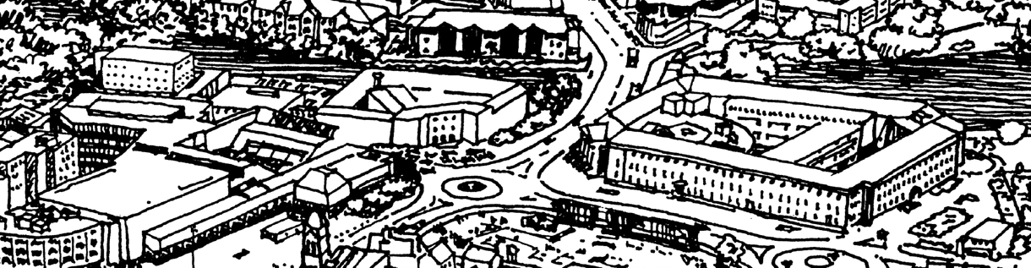
The Institute of Historic
Building Conservation

Application Form
IHBC Affiliate
‘Demonstrate awareness of built and
historic environment conservation practice’

Apply now for formal recognition from April 2022

Registered & Business Office: Jubilee House, High Street, Tisbury, Wiltshire SP3 6HA
Registered as a Charity in England: No. 1061593
Registered as a Charity in Scotland: No. SC041945
Company Limited by Guarantee; registered in England: No.3333780

© IHBC March 2022
IHBC Affiliate Application Form – v. March 2022

1. Introduction to your IHBC Affiliate application

The Institute of Historic Building Conservation (IHBC) is the professional body and charity that supports all aspects of the conservation, care and management of historic and other places and fabric valued as resources, including cultural areas, buildings, interiors and landscapes.
- This form should be used to apply to become an Affiliate of the IHBC as a category that will operate from April 2022, when an Affiliate of the IHBC will be formally registered as being ‘aware’ of built and historic environment conservation practice in line with the IHBC’s conservation models, discussed below, and is bound by the IHBC’s Code of Conduct.
- An IHBC Affiliate is described by the IHBC as an applicant: ‘Confirmed by the IHBC as having demonstrated awareness of built and historic environment conservation practice’.
- No post-nominals are associated with this category of IHBC membership
- From 2022 Affiliate membership must be renewed every five years, based on the submission and approval of the appropriate application form.
- When completed, submit your form and supporting information using the link HERE

BEFORE CONTINUING:
- Please read carefully the guidance below BEFORE completing this form.
- Please use our on-line guidance to ensure that this category of membership is the most appropriate for you.
- Please make sure that you have your registration reference and that your subscription fee is up to date before applying. You can check your details in advance by emailing membershipservices@ihbc.org.uk. If you do not yet have a membership reference number you can register online.
- You are encouraged to include a current and full CV or comparable statement of experience to supplement your application. You can add this as an attachment to your digital submission of this form.
- Note that you will need a suitable person willing and able to endorse the completed form as early as possible in this process.

1.1 Essential Guidance
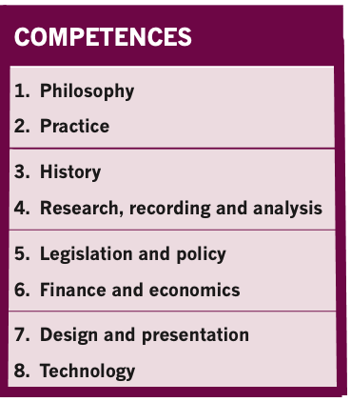
Application and Assessment

Applicants are required to demonstrate an appropriate level of understanding of conservation in the ‘Statement’ section of this form (Section 2). Your ‘Statement’ should outline your understanding of conservation practice against eight core principles and activities in conservation practice, the IHBC’s eight ‘Competences’, listed opposite and in Section 2.
- To be successful, the ‘Statement’ in your application MUST demonstrate ‘Awareness’ of conservation across ALL eight Competences.
- For the purposes of the IHBC’s assessment, being ‘Aware’ is summarised as ‘possessing basic knowledge and skills’.

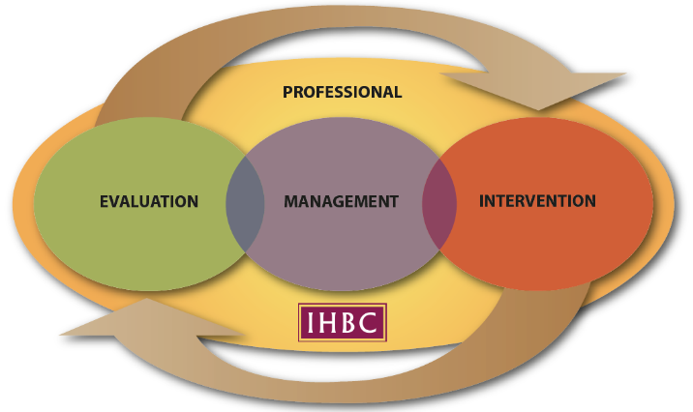
Understanding Conservation and the IHBC Conservation Cycle
To complete the ‘Statement’ effectively, you should appreciate how the eight Competences listed contribute to successful conservation.

The ‘IHBC Conservation Cycle’ diagram, opposite, helps understand how our assessment of the Competences aligns with national and international standards, models and frameworks.

The ‘Cycle’ shows the distinguishing features of any successful conservation process, as reflected in the IHBC’s four ‘Areas of Competence’ – ‘Professional’, ‘Evaluation’, ‘Management’ and ‘Intervention’ - and their respective places in the conservation process. It is presented as a cycle because, while conservation projects will have formal conclusions, the need for care, monitoring and review will continue.

The four Areas of Competence overlap with, and correspond to, familiar aspects of the conservation process. The ‘Professional’ Area of Competence represents the essential infrastructure of conservation: informed oversight that ensures a consistent and coherent standard across the entire cycle of conservation.

The three ‘Practical’ Areas of Competence – Evaluation, Management and Intervention – reflect the three critical stages of successful conservation. ‘Evaluation’ must happen first, to identify and understand the resource to be conserved. Only then can that resource be properly cared for, or ‘Managed’. Finally - informed by the earlier stages – changes, or ‘interventions’ into the resource, can be considered, while these can include the decision not to intervene.

To secure successful conservation the four Areas of Competence must operate in sequence and to an appropriate standard. Specific circumstances will determine the weight given to each Area of Competence both in conservation practice and in the IHBC’s assessment. Operating the Professional ‘Area of Competence’ to a high level is the most cost-effective way to secure successful conservation outcomes.
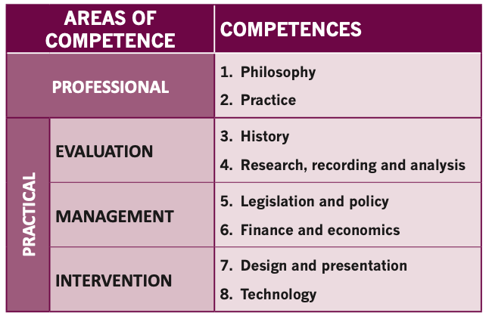
The four Areas of Competence cross-reference to the IHBC Competences, as described in the Table opposite. These are the more familiar areas of conservation practice and should be the focus when completing your ‘Statement’ in section 2.

And remember, in your Statement…
- Be as concise as you can to make your case. It should be possible to cover many or all competences in less than 750 words, often much less.
- Where relevant, be specific and clear about your own input and your conservation-related actions, responsibilities and outcomes, explaining how you were involved and what you contributed or understand in the context of that competence
- Provide clear evidence to support your application, with statements underpinned by information, references and evidence
- Cases may be more than five years old, but do not offer them as evidence without explaining their relevance
- Do not either plagiarise information or claim any work that is not your own. Content taken from your existing work is welcome, but it should be identified as such.
- Do not handwrite forms.

2. Affiliate Statement: Skills, Knowledge & Experience

2.1 ‘Professional’ Area Of Competence

Demonstrate your awareness of Philosophy and Practice

COMPETENCE 1: PHILOSOPHY
Appreciation of the social, cultural, political, aesthetic, economic and environmental values that underpin current conservation policy and practice, its history and its future.
- Outline your awareness of the philosophy of conservation, and how you gained it
- Include an example to help demonstrate your awareness of this competence, such as essays and exercises, projects, courses, volunteering and relevant work experience

Statement and Evidence: Enter your concise evidence for this section below.

1. Summarise your understanding of this competence.

2. Provide a short example of where your understanding of this competence has developed, changed or been reinforced. Include a brief background, describing as relevant your own involvement, what you learnt from it, and how it illustrates your own abilities.

COMPETENCE 2: PRACTICE
Understanding of the wider context of conservation and its professional practice, including knowledge of and ability to interact effectively with all bodies and individuals who have a significant role to play in the field.
- Outline your awareness of the practice of conservation, such as business and project management, planning, regeneration, development, corporate and change management etc., and how you gained it.
- Include an example to help demonstrate your awareness of this competence, such as essays and exercises, projects, courses, volunteering and relevant work experience

Statement and Evidence: Enter your concise evidence for this section below.

1. Summarise your understanding of this competence.

2. Provide a short example of where your understanding of this competence has developed, changed or been reinforced. Include a brief background, describing as relevant your own involvement, what you learnt from it, and how it illustrates your own abilities.

2.2:’Evaluation’ Area Of Competence

Demonstrate your awareness of ‘History’ and ‘Research, Recording and Analysis’

COMPETENCE 3: HISTORY
Knowledge of the history and development of a broad spectrum of the built and historic environment, including the heritage and development of previous cultures and periods as expressed across historic buildings and their details; settlements; urban areas; works of engineering; parks, gardens and other elements of the historic landscape, alongside more detailed knowledge of any specialist areas of interest.
- Outline how you gained your awareness of history and historical perspectives, referring to your interests in historic sites, structures, buildings and areas.
- Include an example to help demonstrate your awareness of this competence, such as essays and exercises, projects, courses, volunteering and relevant work experience

Statement and Evidence: Enter your concise evidence for this section below.

1. Summarise your understanding of this competence.

2. Provide a short example of where your understanding of this competence has developed, changed or been reinforced. Include a brief background, describing as relevant your own involvement, what you learnt from it, and how it illustrates your own abilities.

COMPETENCE 4: RESEARCH, RECORDING AND ANALYSIS
Ability to carry out or commission research, analysis, survey and recording of the historic environment, and to maintain records accordingly.
- Outline your awareness of research and/or related interpretation, recording, and analysis relevant to conservation, and how you gained it.
- Include an example to help demonstrate your awareness of this competence, such as essays and exercises, projects, courses, volunteering and relevant work experience

Statement and Evidence: Enter your concise evidence for this section below.

1. Summarise your understanding of this competence.

2. Provide a short example of where your understanding of this competence has developed, changed or been reinforced. Include a brief background, describing as relevant your own involvement, what you learnt from it, and how it illustrates your own abilities.

2:3 ‘Management’ Area of Competence

Demonstrate your awareness of ‘Legislation and Policy’ and ‘Finance and Economics’

COMPETENCE 5: LEGISLATION AND POLICY
Knowledge of the legislative and policy framework for the conservation of the built and historic environment, its formulation and application in planning both locally and nationally and an awareness of other relevant legislation and policies alongside an understanding of the relationship between these and planning legislation and policy relating to conservation.

- Outline how you gained your awareness of conservation legislation and policy and its operation within the planning process.
- Include an example to help demonstrate your awareness of this competence, such as essays and exercises, projects, courses, volunteering and relevant work experience

Statement and Evidence: Enter your concise evidence for this section below.

1. Summarise your understanding of this competence.

2. Provide a short example of where your understanding of this competence has developed, changed or been reinforced. Include a brief background, describing as relevant your own involvement, what you learnt from it, and how it illustrates your own abilities.

COMPETENCE 6: FINANCE AND ECONOMICS
Understanding of processes for procuring building or other historic environment works and facilitating appropriate management, development and regeneration projects, including finance, valuation, cost planning and contracts, with specific reference to historic buildings, landscapes, sites and areas.

- Outline how you gained your awareness of finance and economics as they relate to conservation processes.
- Include an example to help demonstrate your awareness of this competence, such as essays and exercises, projects, courses, volunteering and relevant work experience

Statement and Evidence: Enter your concise evidence for this section below.

1. Summarise your understanding of this competence.

2. Provide a short example of where your understanding of this competence has developed, changed or been reinforced. Include a brief background, describing as relevant your own involvement, what you learnt from it, and how it illustrates your own abilities.

2.4 ‘Intervention’ Area of Competence

Demonstrate your awareness of ‘Design Practice and Presentation’ and ‘Technology’

COMPETENCE 7: DESIGN PRACTICE AND PRESENTATION
Ability to analyse, evaluate and/or promote quality in design, existing and proposed, covering details, buildings and areas as well as rural and urban contexts, and to present and explain such quality in ways understandable to both professional and lay audiences.

- Specify how you gained your knowledge and understanding of design and its presentation – new and old – in culturally sensitive and/or historic places, referring in particular to the communication, interpretations and promotion of appropriate change across diverse audiences.
- Include an example to help demonstrate your awareness of this competence, such as essays and exercises, projects, courses, volunteering and relevant work experience

Statement and Evidence: Enter your concise evidence for this section below.

1. Summarise your understanding of this competence.

2. Provide a short example of where your understanding of this competence has developed, changed or been reinforced. Include a brief background, describing as relevant your own involvement, what you learnt from it, and how it illustrates your own abilities.

COMPETENCE 8: TECHNOLOGY
Knowledge of building construction of all periods, the characteristics of structures, the nature and properties of building materials and appropriate methods of care, repair, alteration and improvement of historic fabric.
- Outline how you gained your awareness of building, construction and related technology, referring to a wide range of types and methods.
- Include an example to help demonstrate your awareness of this competence, such as essays and exercises, projects, courses, volunteering and relevant work experience

Statement and Evidence: Enter your concise evidence for this section below.

1. Summarise your understanding of this competence.

2. Provide a short example of where your understanding of this competence has developed, changed or been reinforced. Include a brief background, describing as relevant your own involvement, what you learnt from it, and how it illustrates your own abilities.

3. Endorsement

3.1 Endorsement of Application (To be signed by the person supporting the statement).

I have read the IHBC Affiliate Statement prepared by [ ] and have discussed it with the applicant. I see no areas or matters that conflict with my knowledge of the candidate or their work.

Full Name:
Title/Role:
Address:
Email address:
IHBC membership reference number (if relevant):

Insert Digital signature below OR put an x where indicated if you do not have one
SIGNED: Alternative to Signature (enter X):
Date:

3.2 Confirmation by Applicant

FORMAL STATEMENTS
All the information in this form is correct to the best of my knowledge
I agree to abide by the IHBC’s Code of Conduct to the best of my ability

Full Name:
IHBC membership reference number (as available):
Email:

Insert Digital signature below OR put an x where indicated if you do not have one
SIGNED: Alternative to Signature (enter X):

Applicants should submit the completed form online, together with CV and any supporting papers HERE
Queries may be submitted to membershipservices@ihbc.org.uk

